Pokhara University

Level: Bachelor | Semester – Fall | Year : 2010
Programme: BE |  | Full Marks : 100
 |  | Pass Marks: 45
Course: Engineering Mathematics III |  | Time : 3hrs.

Candidates are required to give their answers in their own words as far as practicable.
The figures in the margin indicate full marks.

Attempt all the questions.

1. | - Define transpose of the matrix. Show that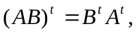where A and B are matrices of specific order.  OR  Show that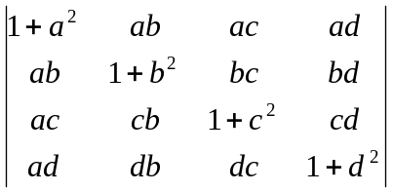=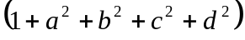  by using the properties of determinant.  b) Define rank of the matrix. Find the rank of the matrix 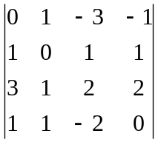 | 8  7
2. | - Define consistence and inconsistence of a system of linear equations. Check consistence of given system of linear equation.  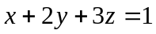  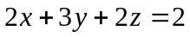  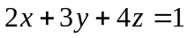  - Find the Eigen value and Eigen vector of the matrix  A=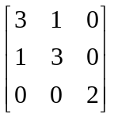 | 7  8
3. | a) A particle moves along the curve 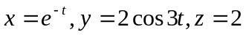 sin 3t where t is the time. Determine its velocity and acceleration vectors and also the magnitude of velocity and acceleration at t = 0.  b) Define directional derivative of the function f in the direction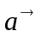. Derive the expression of directional derivative of f in the direction . Find directional derivative of 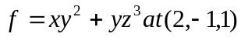 along the direction of the normal to the surface S: 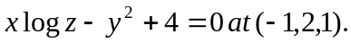 | 7  8
4. | - State Greens theorem in plane. Evaluate 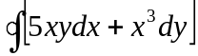, where C is the closed curve consisting of the graph of  and 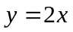between the points (0, 0) and (2, 4).  - Evaluate 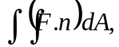 where 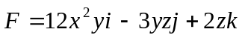, and S is the surface of the plane 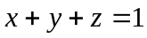in first octant. | 7  8
5. | - Prove that the infinite series 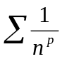is convergent for p >1 and divergent for p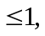.  - Find the interval, centre and radius of convergence of the power series 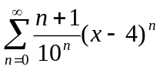  OR  Find Maclaurin's series of the function 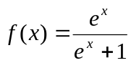. | 7  8
6. | a) Find the Fourier series representation of the periodic function 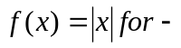π < x < π. Using it show that 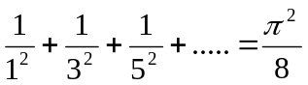  b) Find Fourier sine as well as cosine series of the function 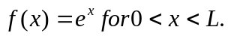 | 7  8
7. | Solve the following:  - Let T: R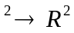 be a transformation which is defined by 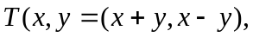check the linearity of T.  - Test the convergence of the series 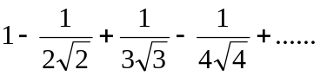  - Evaluate 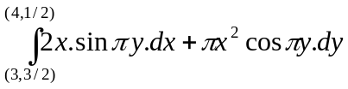)  - If 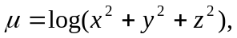find div (grad)  - Find the period of f(x) = 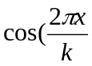) | 5x2

